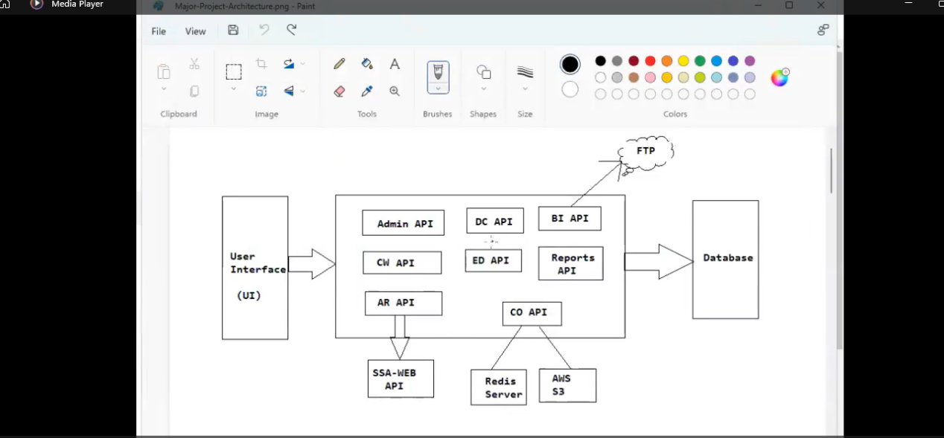

Project Mock-up Screens

Login page : common for ALL users

ADMIN User Mock Pages

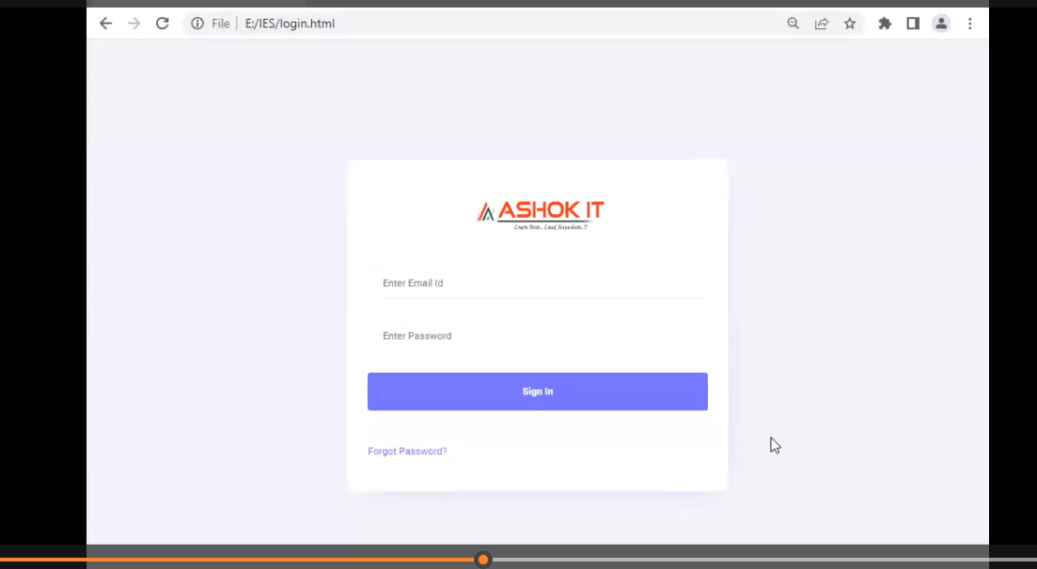
After Login Dash Bord page for All user
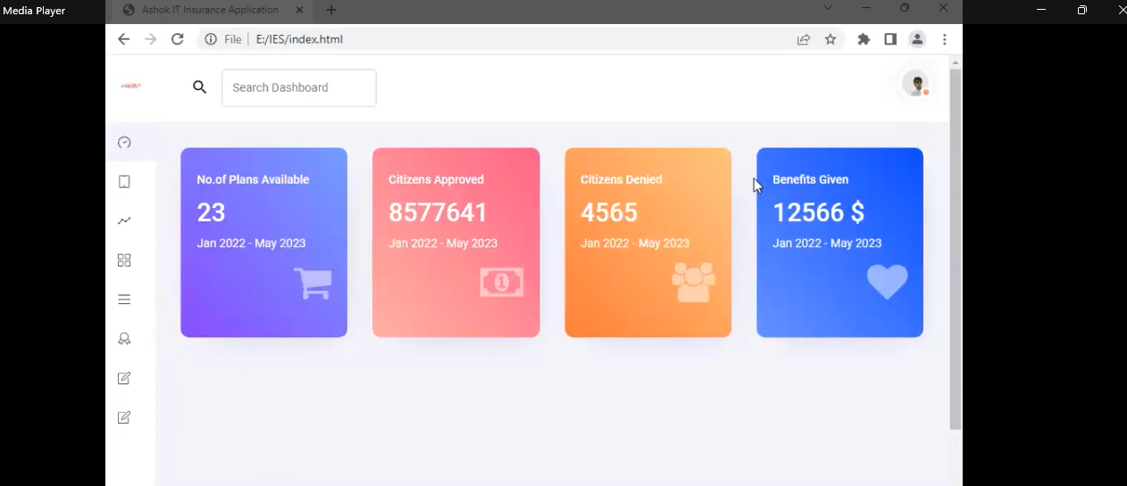

Admin User have below Options - other users don’t have this rights to access

- Create Account 2) View All Accounts 3) Create Plan 4) View Plans

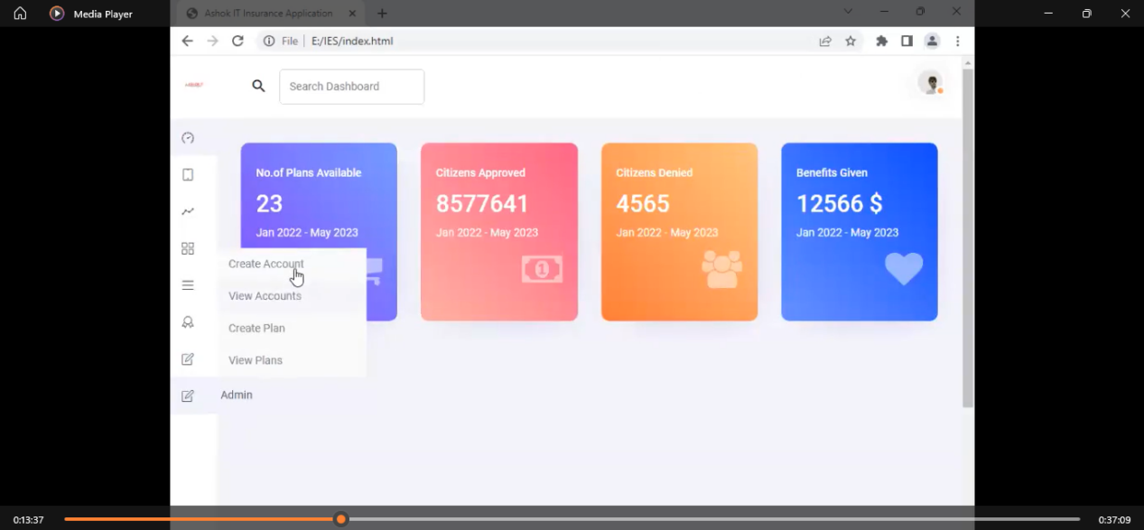

ADMIN page to create User Account : this should Access for only ADMIN credentials others cant create Account

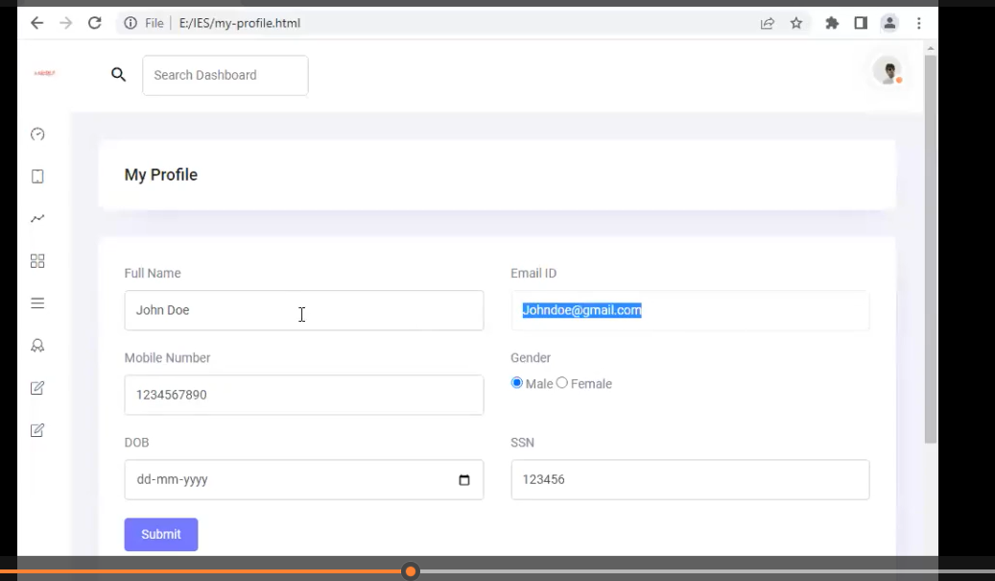

View Accounts Page with below SS options include Search Operation based on SSN number

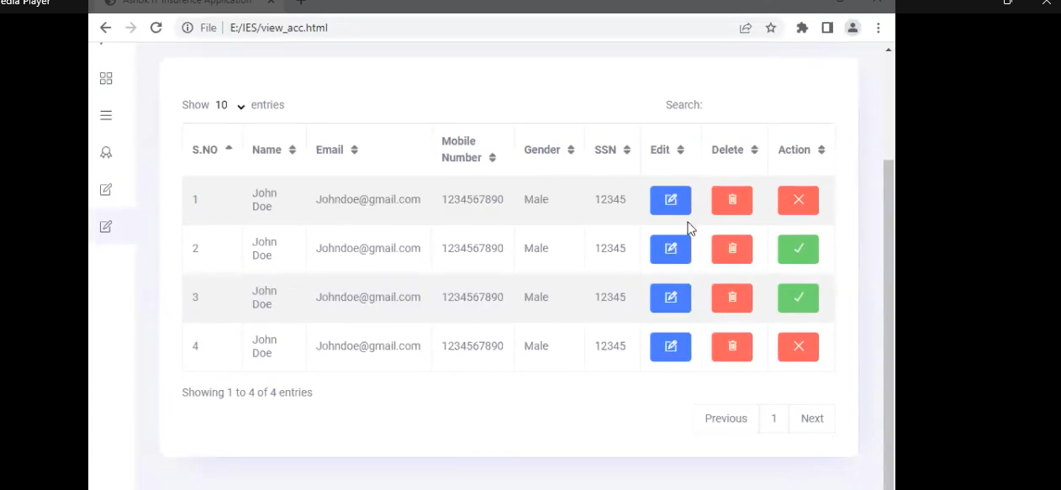

Create PLAN page

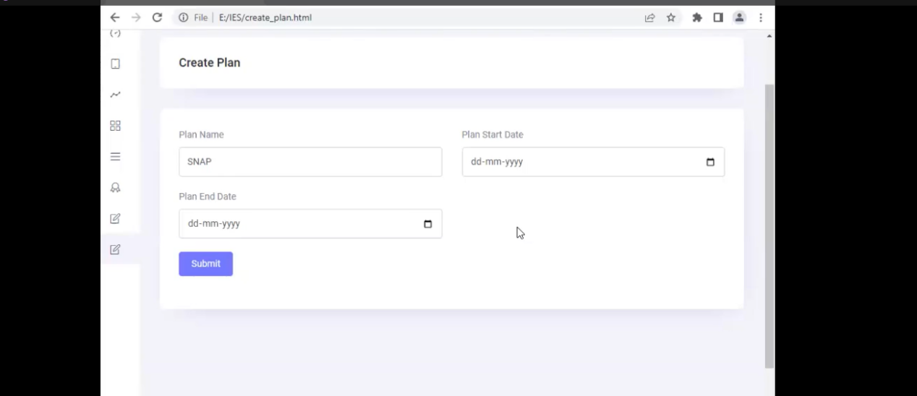
View Plans PAGE with below SS options include Search Operation based on plan Name

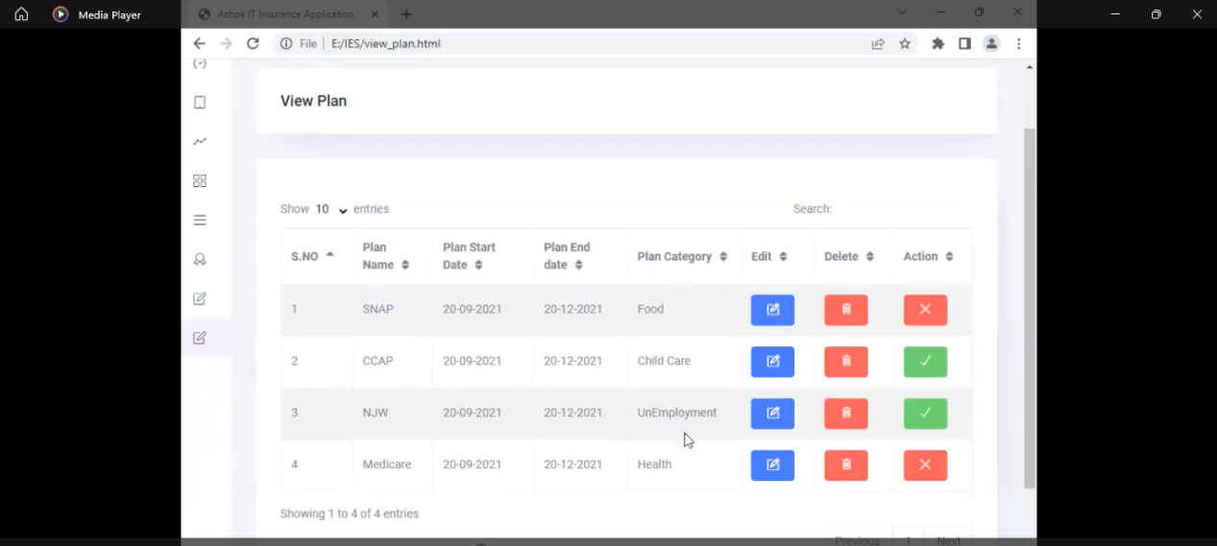

Case Worker Mock pages - nothing but which are the user created by ADMIN user

Onces Admin User create Account for Officer then he will get a mail to unlock the account after unlock the account he can login with his credentials
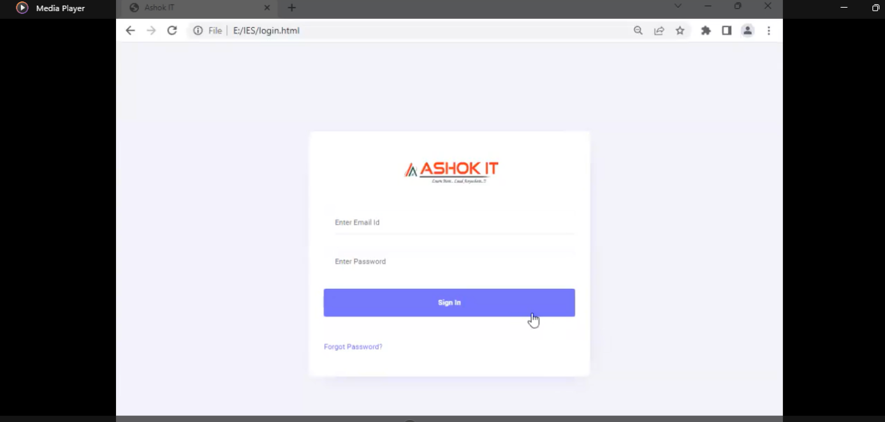

That Login user Officer have Option to Edit his Profile
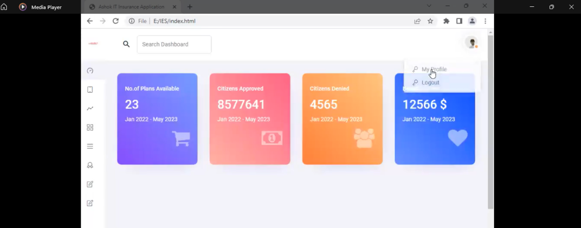

Profile Edit he can do except Email the Email so Email can editable or deleted by Only Admin user
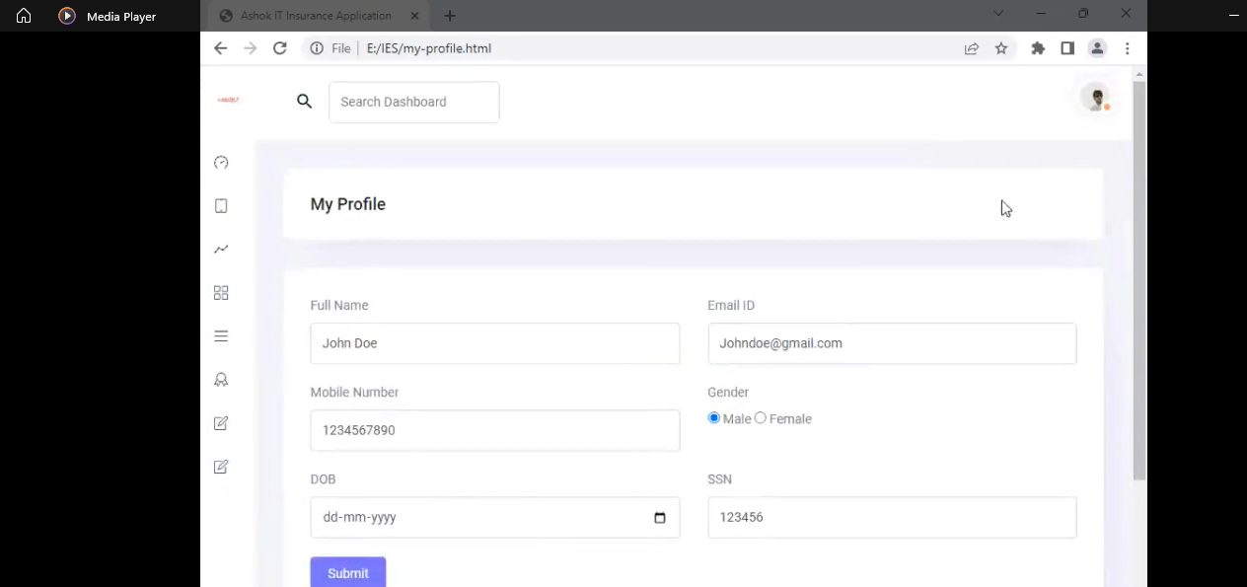

AR API - application registration nothing but applying loan by Case worker for citizen Users

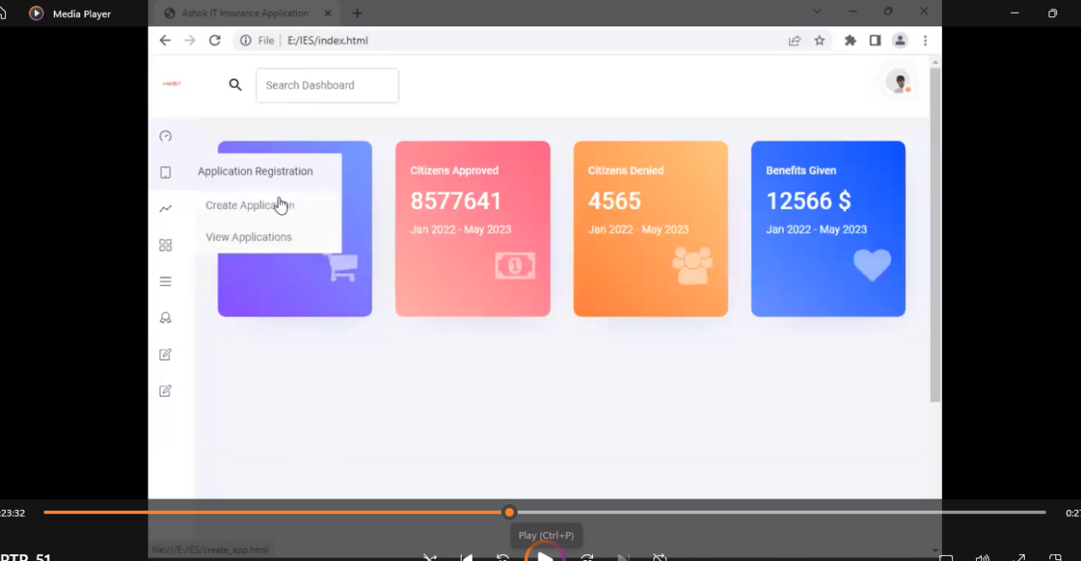

Create Application Page - for citizen users - details are Citizen user detais

On click on Submit button we need to call SSA-WEB-API - to check given SSN Number is correct or not and is is residential of particular state if is residential means we need to create application else error need to display

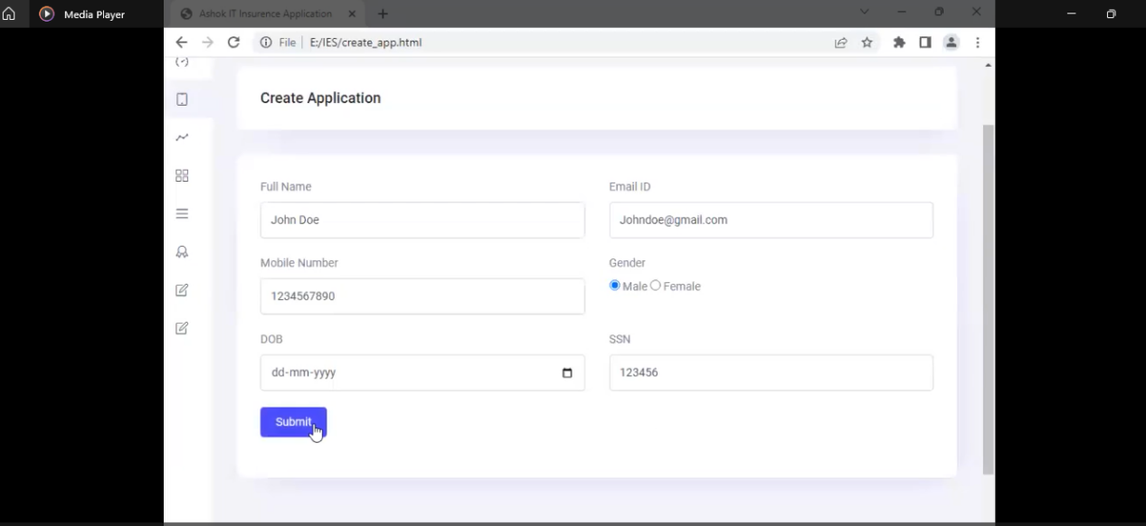

If all ok application needs to create
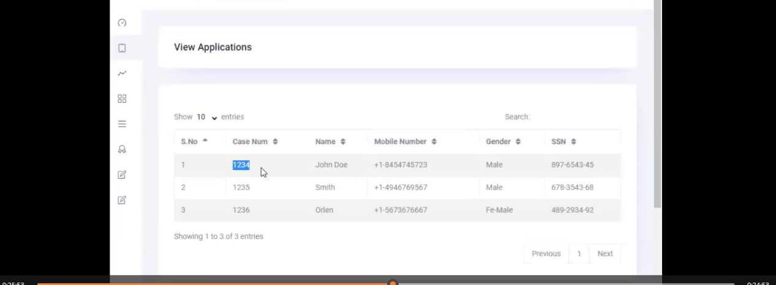

Case NUB is a hyper link - when user click on this he can choose what plan he need like below

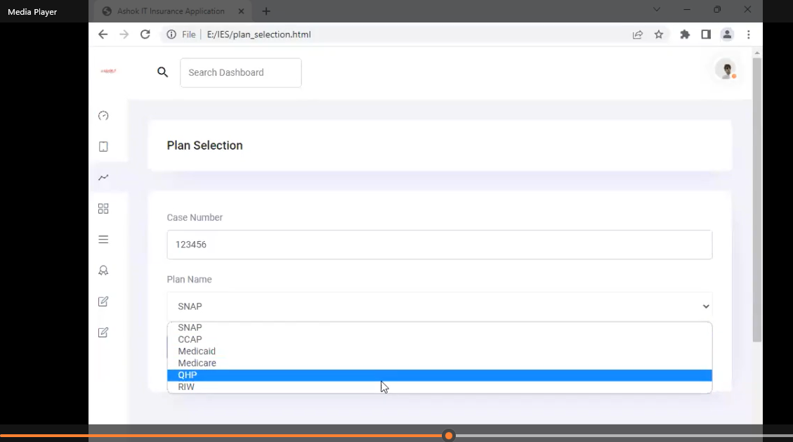

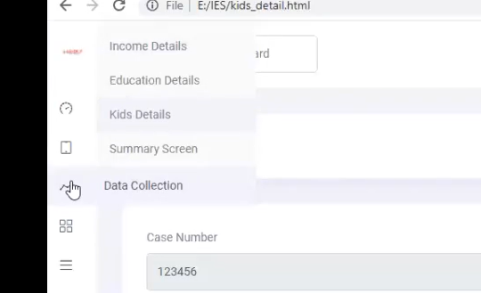

IF User Selct SNAP means
he to to provide Income Details and remain details one by one like below SS
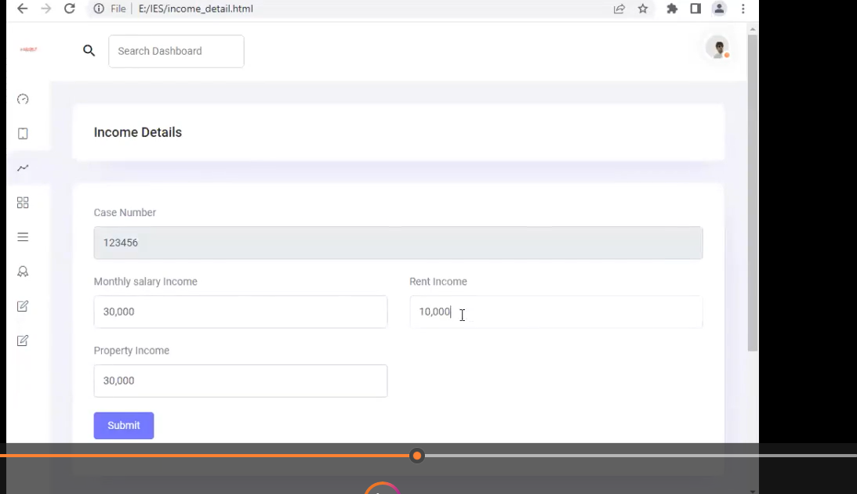

NEXT Education details

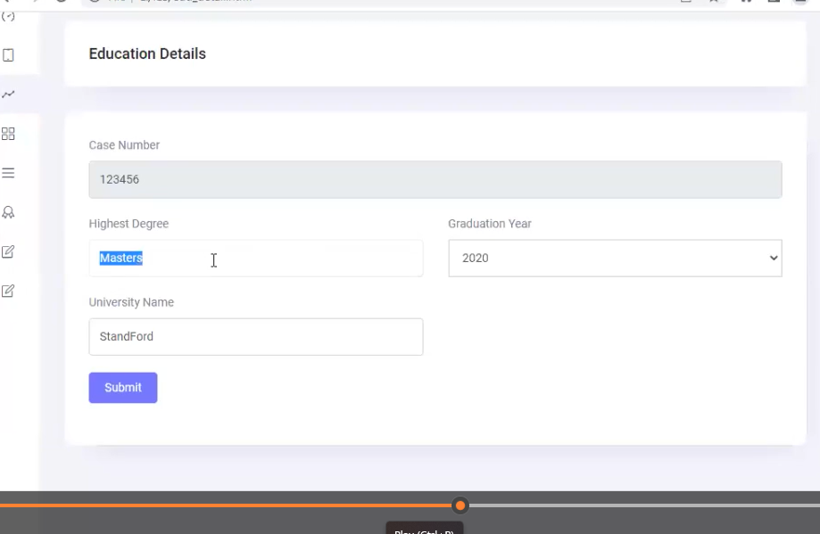

NEXT Kids details

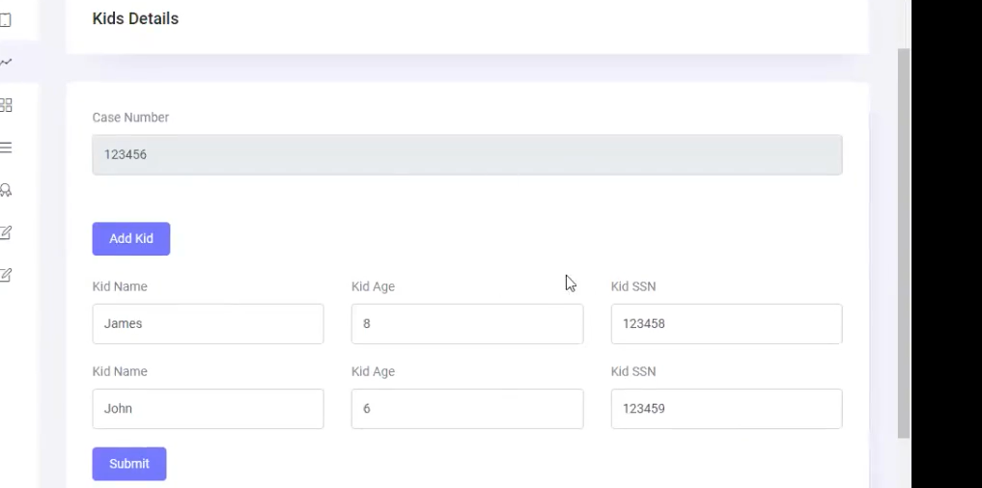

Summary Screen
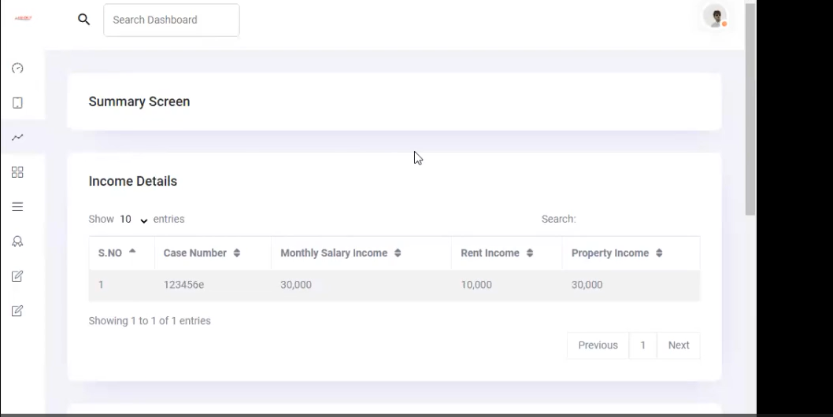

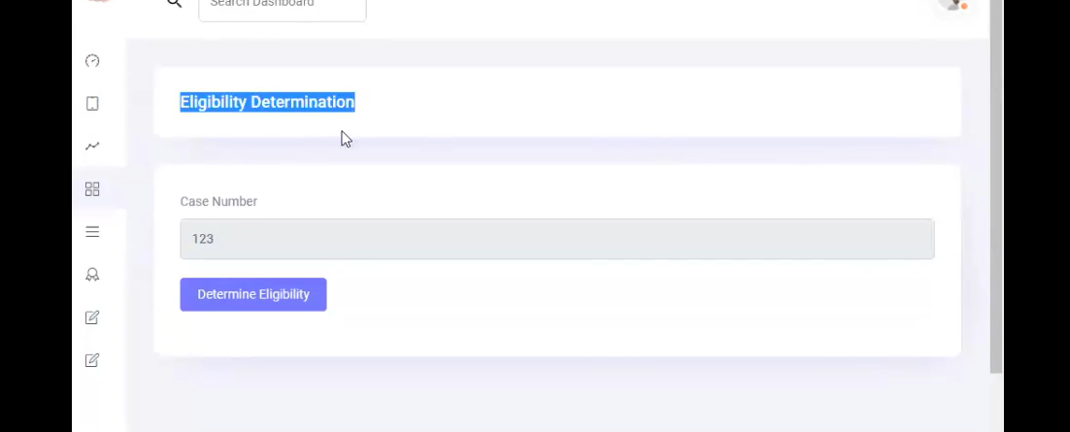

Once ED check completed we need to show approved or not : and not approved means Denial reason

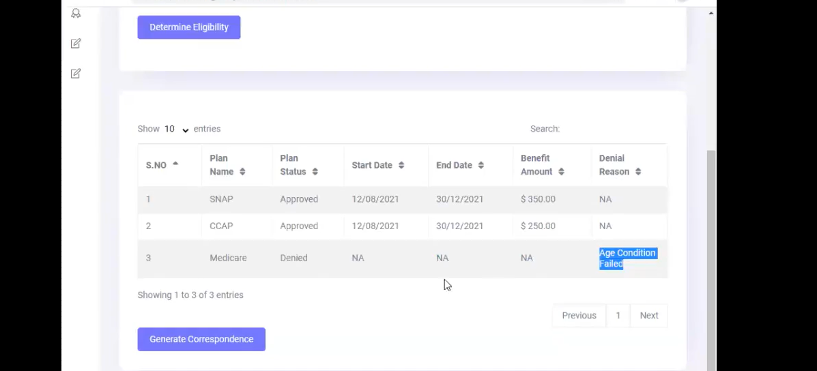

Onces user click on Generate Correspondences CO API is the responsible to send PDF’s related user which is showing like Below SS
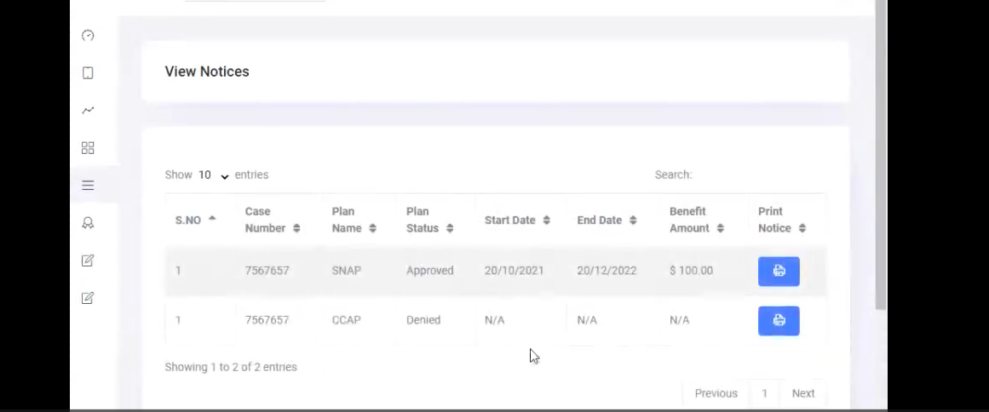

Also the CO Module have below two Options as well Pending & History

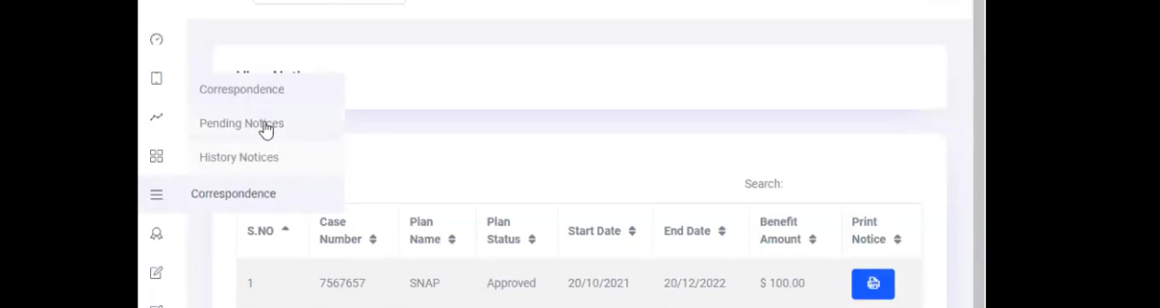

If user click on Pending and based on search user pending PDF generated items we need to show

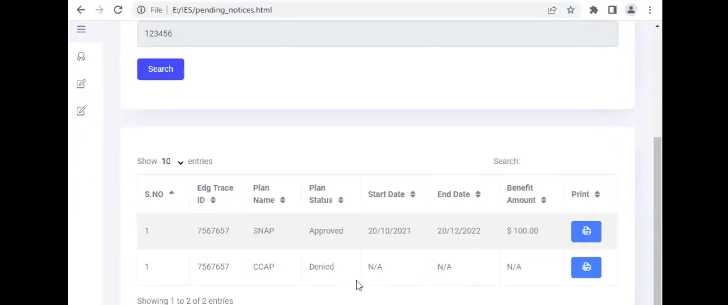

If the user select on History means we need to display already PDF generated items we need to show
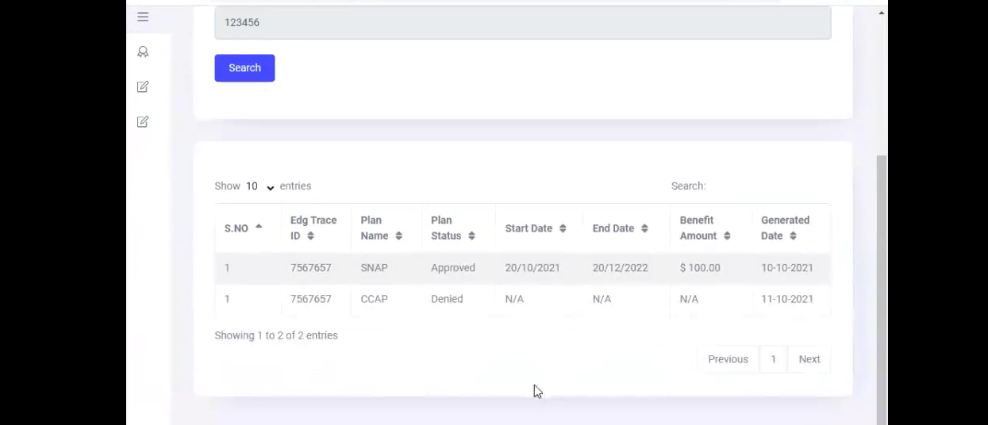

Final One BI API’s

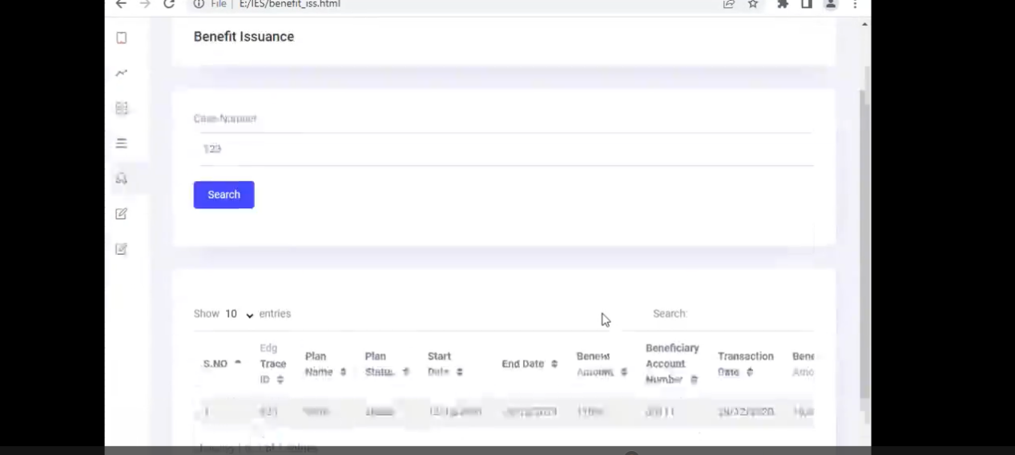

Reports Module to send the Reports over all records based on searched items
Download option AS - PDF and Excel

